Meta Description:
Learn 7 proven ways UAE businesses can generate leads without spending too much on ads. From website to referrals, start growing your sales sustainably today!

How UAE Businesses Can Get Leads Without Spending Too Much on Ads
Have you felt like your ad spend is disappearing before your eyes? And your ad money is turning into waste before your eyes, quicker than you thought. You are not alone. We all have experienced this; we look at the analytics with curiosity, ready to find out where our dear leads happen to be. A large expenditure on advertising might leave you feeling like you are in a war, a war where... the success might be impossible.
However, it is impossible to keep spending money on ads all the time, and get results not up to the mark as you were expecting in terms of return. What then, when the answer is not to yell louder, but you need to listen more carefully to solve your Lead generation UAE problems. Here is how your UAE business can generate more leads without spending too much on ads:

Why Ad Struggle Is Real?
The UAE market is alive, competitive, and costly. There are crowded platforms where everyone is struggling to get customer attention. The bidding war hikes prices in a single night. Here is why ad struggle is real in the UAE:
- The cost associated with the ads is unreal, and sometimes it can’t provide you expected results.
- Low-cost lead generation UAE often proves unreliable because of many competitors in the market.
- Consumers are wiser than before because they skip through ads that they find not relevant to them in any way.
- A dependency on paid ads will leave you just as quickly in trouble as the budget runs low.
That’s why you need to find an alternative to your ad struggle to save your capital and business in the UAE. By finding the alternatives and implementing your custom organic marketing UAE, you can easily get better results.

Focus on Solving Problems, Not Just Selling
Put the hard sell aside for a minute. As an owner of a UAE business, you need to ask yourself questions like:
- What is actually the actual pain of your ideal customer?
- What are the things that will not allow them to sleep at night?
- Where are those pain points in your strategy?
When you concentrate single-mindedly on customers' issues, nothing fails like giving authentic, beneficial solutions. Your customers begin to regard you as the maestro and not another seller. That is where the interest of your customers rises and your free lead generation strategies start to work exactly as you predicted.

7 Lead Generation Strategies that Will Work Perfectly For Your UAE Business:

Leverage Content Marketing
Think of having someone (a salesperson) work all the time, answering questions and developing trust in you even when you are asleep. That is what content marketing should be. This is how you can leverage content marketing to generate leads for your small business in the UAE:
- Craft blogs that will address such UAE market challenges head-on. Write a practical guide on “Tips and strategies for generating high-quality leads in the UAE” or other relevant blogs for engagement.
- Post case studies illustrating how you did practical things that helped real Dubai clients deal with real local problems.
- Use all relevant search engine optimization strategies to speed up your small business lead generation process with better outcomes, like more organic traffic and customer engagement.

Build a Strong Social Media Presence
Social media are not mere megaphones of promotions, but crowded marketplaces to generate new ideas for better engagement. Here is how you can build a strong social media presence for your UAE business:
- Do not send out broadcasts of how awesome your latest offer is, but instead run snippets of your problem-solving material.
- Dive into the activity of specialised LinkedIn groups or Facebook forums on the UAE or your sector. Give answers carefully.
- On Instagram, you can use Stories to offer some short advice or a backstage glimpse of how a problem is solved for a client.
- Social sites such as LinkedIn are B2B lead generation juggernauts in the UAE, so you need to focus on that platform too.
Our social media services will let you build relationships and highlight your expertise, and help your UAE business reach out to your customers who are truly interested in your products and services.

Harness the Power of Referrals
The customers who have been satisfied with you are already your greatest advocates! Individuals have a lot more trust in peers than in any advertisement. Here are some steps you can consider the harness the power of referrals:
- Encourage an active referral. Simplify it and make it worthy of your customer's time. An easy way to say, i.e., loved our service? Refer a friend, and you both get some great benefits
- Consider the high level of hospitality and word-of-mouth tradition the UAE has to proudly offer-use it!
- Post those success stories in high places. Once people viewing you as potential leads see that you have done well to take care of issues faced by others similar to them practically, your credibility takes a big spike.
That is social proof at its finest, and this is very persuasive when it comes to generating leads in the UAE.

BNI UAE Case Study: Building a Dh3.7 Billion Empire Through Structured Referrals 2

Company Background & Challenge
BNI UAE (Business Network International), the local franchise of the world’s largest referral networking organization, faced a common UAE business dilemma: high customer acquisition costs in a competitive market and low trust in transactional advertising. When Bijay Shah became National Director, he recognized that traditional ads were inefficient for SMEs seeking sustainable growth. The challenge was to create a scalable, trust-based lead generation system suited to the UAE’s relationship-driven economy.

The Referral Strategy: Givers Gain® Philosophy
The accountability-driven model that was adopted by BNI UAE in UAE was structured and based on the principle of Givers Gain 2021. This method was based on the ideology that by helping people succeed, the better off their business is. Key components:

- Weekly Chapter Meetings
- Structured agendas
- Quantifiable Tracking
- Cultural Adaptation

Real Impact: Referrals Turned into Revenue
- Dh3.7 billion in closed business from referrals over 20 years.
- 50,000+ referrals logged annually across 40+ chapters.
- Dentist-to-Developer Mega-Deal
- Lower Customer Acquisition Cost (CAC)

Networking and Community Engagement
Digital is big, but real human connection can never be underestimated, particularly within the relationship-oriented UAE market. Here are some steps your business can take to get maximum benefits from the power of networking and community engagement:
- Visit industry events or conferences, or virtual webinars. It may not be enough to collect business cards only, but focus more on having conversations. Pay more attention to making a pitch.
- Partner up with other non-competing yet complementary businesses to deliver a joint value to your customers, e.g., perhaps co-hosting a webinar that addresses a common customer challenge.
- Provide a free workshop or a slot consultation. It is not an immediate hard sell, but it will show your value and expertise in person (or on-screen).
By implementing these strategies, you can easily upscale your strategies of organic marketing UAE to achieve desired results.

Optimize Your Website
Your site is not, as many people think, an electronic brochure, but your greatest lead-gathering medium. To know whether your business site is fully optimized or not, you can ask some questions for yourself:
- Does it instantly send the signal that you are aware of the problems of the visitors?
- Does it not provide evident routes to solutions?
- Does it contain strong, powerful call-to-actions (CTAs)?
Here are some steps that an owner of a UAE business can take to improve the effectiveness of their website:
- Add an About Us page because it will help to build a connection with your customers on an emotional level
- Add options like Get Your Free Efficiency Audit or Download the UAE Logistics Checklist.
- You need to provide lead magnets, useful, potentially valuable resources such as templates, e-books, or tools in exchange for an email address.
- Make sure your site is fast and optimised on mobile, first impressions count the most!
By implementing these steps, you can easily cut short your spending on ads and get better results regarding lead generation in the UAE.

Use Email Marketing Strategically
It is good to build that email list through your lead magnets. Now take good care of it! If you are wondering how you can do that, let us highlight some working steps that will surely help your UAE business:
- Do not spam the inbox of your customers.
- Write individual emails that will be a continuation of the problem-solving process.
- Divide your list into segments.
- Provide usable information, insider advice, or go in-depth on issues of interest to your customers.
You need to foster those leads through nurturing content that is valuable. And consider this an ongoing dialogue in which you keep showing them that you have the answers you seek. It establishes know, like, and trust, and heats up cold leads. Do not underrate this channel!

Encourage Customer Reviews and Testimonials
Reviews and testimonials by the customers will be dynamite in regards to lead generation UAE. If you want to take advantage of this process, here are some steps you can take that surely will help you:
- Make sure to actively solicit feedback from happy clients.
- Promote these impactful narratives everywhere, including your home page on your site and other pages fully focused on case studies, on social media, and even in your email signatures.
- Sharing special quotes regarding how you solve problems is the best way to get the attention of your customers..
- Make sure you have the ability to deal with criticism and give unbeatable social evidence.

Measure and Improve Your Strategies
As they often say, “you cannot improve what cannot be measured”. The following are some steps you can consider to measure and improve the performance of your strategies:
- Track everything related to the performance of your current working strategies.
- Use analytics to understand where your site traffic is originating
- Analyze the content pieces that are creating the greatest response.
- Research on which social posts are causing the greatest response, and which sources of leads are best converting to paying customers.
- Which is the lead generation UAE strategy with the greatest ROI?
- Listen to the reviews of the customers, like what issues are they bringing up the most?
- Make sure you put every effort into the detailed analysis of the data.
- Abandon those things that are not working and quadruple down on those that are proving desired results.
The reason why some strategies have sustainability in the long run is because of analysis run on them and room for constant improvement using actual evidence.

Conclusion
UAE entrepreneurs, therefore, the road to lead generation in the UAE without emptying the treasury is not terribly mysterious. The bottom line is a fundamental change with a focus on problem-solving instead of product pushing. Put your energy into generating a lot of value. Ensure that you are the authority that your ideal customers will turn to. Use content, the power of social validation, intelligent networking, and digital tools.
It takes commitment and hard work, yes. Yet the outcome? A regular flow of hot leads who are already familiarised, like, and trust you. That is sustainable growth that is based on a solid foundation, not on a sandy desert. For more information related to lead generation UAE, you can visit our lead generation services page to book a free consultation or download our free lead generation guide for UAE businesses.
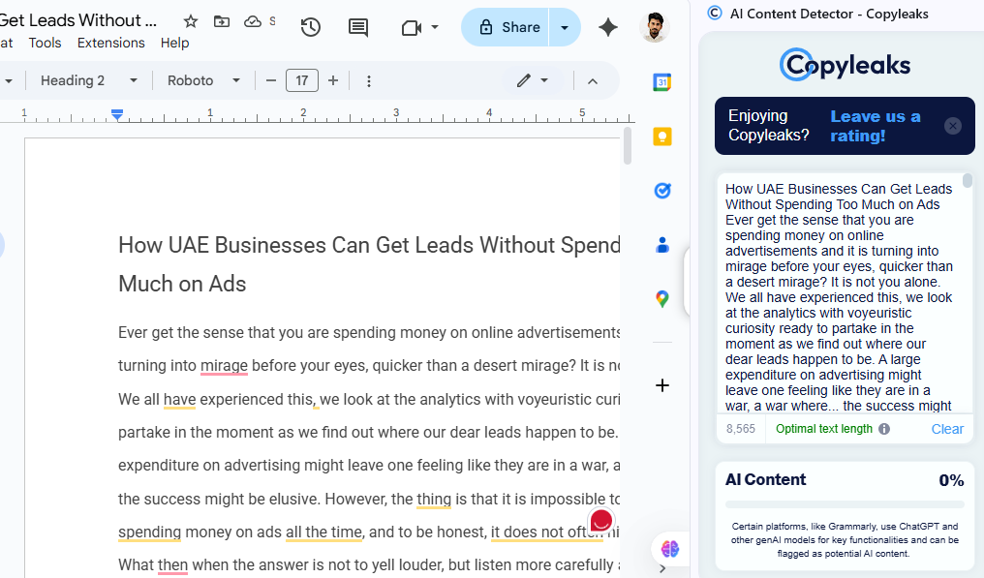

1. Overall Blog Audit Ranking
Score: 6.8 / 10
Here’s why:
- Strengths
  - Clear topic targeting (“UAE business lead generation without ads”)
  - Good range of actionable tips (content marketing, referrals, networking, etc.)
  - Some UAE-specific localisation (mention of market, examples, locations)
  - Has a meta description (though it could be improved for clickability)
- Weaknesses
  - Language is repetitive and sometimes awkward, which hurts readability.
  - Some headings are unclear or too long for SEO.
  - Inconsistent tone — sometimes conversational, sometimes overly formal.
  - Overuse of filler words and vague expressions (“thing is,” “truth beats every time”) that dilute authority.
  - SEO opportunities missed (keyword consistency, subheading optimization, internal linking).
  - Paragraphs are too long, making it harder to scan — big issue for online readers.
  - Meta description not compelling enough to drive clicks.

2. Detailed Issue Highlighting

A. Structure & Readability Issues
- Meta Description
  - Current: "Generate quality leads for your UAE business without expensive ads with proven strategies, including content marketing, referrals, and much more."
  - Issue: Too generic; lacks urgency or emotional pull. Could include a number or benefit statement.
  - Example fix: "Learn 7 proven ways UAE businesses can generate quality leads without expensive ads — from content marketing to referrals — and grow your sales sustainably."
- Headings
  - Some headings are long (“Why Ad Struggle Is Real (And it Leads To Struggle Here)”).
  - Overuse of vague phrasing instead of keyword-driven headings.
  - Example: “The Golden Shift: Solve Issues, Don't Just Sell” could be “Focus on Solving Customer Problems, Not Just Selling” — clearer and keyword-rich.
- Paragraph Length
  - Many are 6–10 lines long. Online best practice is 2–4 lines per paragraph for scannability.
  - Example: The first paragraph could be split into 2–3 smaller chunks for better engagement.

B. Language & Grammar
- Awkward phrases:
  - “Ever get the sense that you are spending money on online advertisements and it is turning into waste before your eyes” → better: “Ever feel like your ad spend is disappearing before your eyes?”
  - “Nothing fails like giving authentic, beneficial solutions” — likely intended to mean “Nothing works better than…”
  - “Truth beats, every time!” — sounds informal and unclear; replace with “Truth wins every time.”
  - “Lead generation UAE fuel” — feels forced and unnatural.
- Repetition:
  - “That’s why you need to find alternatives…” appears twice back-to-back.
  - Multiple uses of “problems” and “solutions” in close succession without synonyms.
- Inconsistency in tenses:
  - Some sections use present tense, others shift unnecessarily.
- Redundant fillers:
  - “To be honest,” “the thing is,” “in any way,” “you stop being a fictional character that is solving fictional issues” (last one is confusing).

C. SEO & Content Optimization
- Keyword Use:
  - “Lead generation UAE” appears a few times, but keyword density is low and not naturally integrated into headings/subheadings.
  - Missing secondary keywords: “low-cost lead generation UAE,” “free lead generation strategies,” “organic marketing UAE,” “small business lead generation.”
- H1/H2 hierarchy:
  - H1 should only be the main title (“How UAE Businesses Can Get Leads Without Spending Too Much on Ads”).
  - Subtopics should be H2, and supporting points as H3.
- Internal Linking:
  - No links to related content, service pages, or case studies. This is a big missed SEO opportunity.
- CTA Optimization:
  - Blog ends with a summary, but lacks a strong single call-to-action (e.g., “Book a Free Consultation” or “Download Our Free Lead Generation Guide for UAE Businesses”).

D. Engagement Issues
- Tone sometimes flips from authoritative to overly casual, which may hurt credibility.
- UAE localisation could be stronger — you mention “UAE market” but don’t give specific local examples (e.g., real industries, success stories, actual UAE networking events).
- Some advice is generic and could apply anywhere, missing the “why this matters in UAE” factor.

3. Recommended Improvements
- Rewrite the meta description to be more clickable and benefit-driven.
- Shorten paragraphs to improve readability on mobile.
- Replace vague headings with keyword-rich ones.
- Fix awkward phrasing and remove redundant fillers.
- Boost UAE-specific context to stand out from generic lead-gen articles.
- Add 2–3 internal links to relevant pages/services.
- End with a single, clear CTA encouraging readers to take the next step.
- Include examples or mini case studies to strengthen trust and authority.
- Increase SEO keyword integration while keeping it natural.

